Prehistoric tomb surveying (7)
Dolmens along the German Baltic coasts

Dirk Kruithof, September 2019

The current paper makes part of a broader study through which the existence of a prehistoric geometry was tracked down. Different stages of tomb setups found at consecutive times and in various areas in Europe form the steppingstones towards the chronicled geometry in ancient mathematical texts. The current paper focuses on one of these areas, the German Baltic coasts. It confirms that the setup and orientation of the studied dolmens can be understood within a grid-of-squares geometry (see PTS-1 ). Grid lines and diagonals through adjacent squares determine the layout of the ground plan of the tombs.

The measuring method

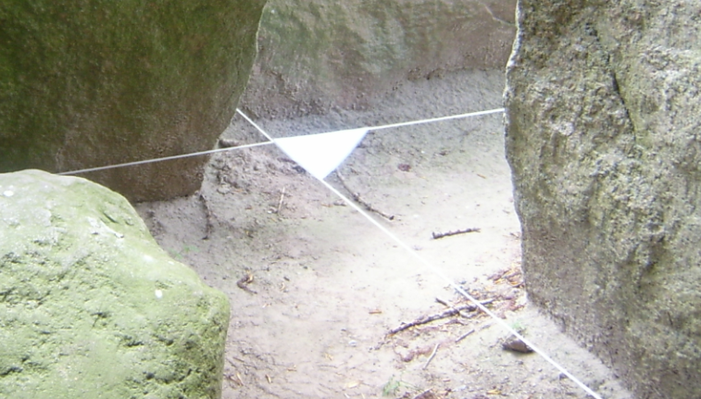
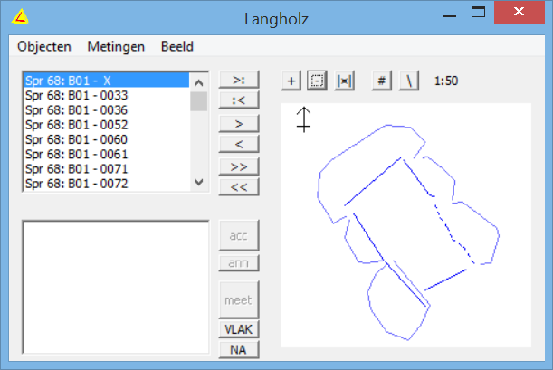
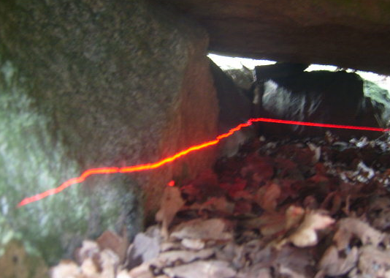

The measurements of this study can be divided into two methods: The method used in Mecklenburg and the one in Schleswig-Holstein. During the first week of May 2007 a few selected ground plans in Mecklenburg were measured by means of a handheld sighting compass (Recta DP-10, ±0.3º), a goniometer, a water level, a tape measurer and rope. Levelled sightlines were constructed by means of water level and rope and then the orientation of those lines was taken by the sighting compass. Inside a dolmen the orientations were derived from already measured ones using the goniometer. Additionally, all sizes of and distances between sightlines were taken in order to check the geometrical forms that rolled out. Although the instruments were easy to carry, the measuring method was very time consuming. Therefore, a small total-station-like measuring tool was developed that combined an electronic angle measurer (Stabila, ±0.1º) and a laser distance measurer (Leica D5, ±0.5mm). This tool together with a laser leveller (KBW-0629, ±1mm/m) was used in
Figure 1
Measuring the angle between two levelled sightlines in Mecklenburg.
Figure 3
Plotting a 2D cross-section. A laser-leveller is used to project a cross-section on the stones. With an electronic angle and distance measurer the 2D data of the curves is taken. The data is inputted to the application SiteMsm.

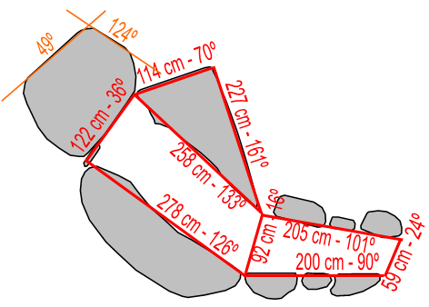
Figure 2
Dolmen 326 of Neu Gaarz.
The ground plan evolves as the result of the measured orientations, sizes and distances.

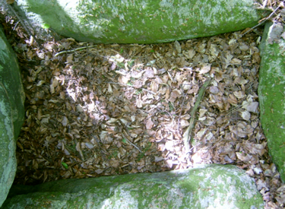
Schleswig-Holstein in July 2011. A session started off by setting up a cross-section of a tomb directly on the stones. Small stickers were attached to the stones at the levelled laser line, and thereby the curves of the stones could be measured in a horizontal plane. The measuring tool was calibrated for true north using a sighting compass (Recta DP-10, ±0.3º) and next the distances and corresponding angles of all stickers were measured and processed. The processing was done by the for this purpose developed application SiteMsm. On the fly it showed the ground plan
Figure 4
Urdolmen 358 of Thelkow.
The ground plan encompasses a Pythagorean triangle (3×4×5) as known from the grid-of-squares geometry.
of the tomb so that faulty measurements could be corrected on the site. The measurement fault was 1 cm per meter at most, which is less than 1º in azimuth.

The tomb selection

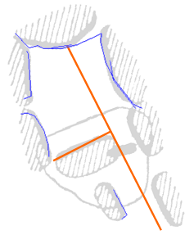
The dolmens were selected along holyday routes via the internet and the atlas of Sprockhoff. Larger tombs were avoided for two reasons: It would take to much time to measure them and the number of relationships between features grows exponentially by the number of stones and interstices. In small tombs the easier and more comprehensible setups are expected
Figure 5
Dolmen 91 of Hemmelmark.
The measured data (blue) is used as an overlay over the ground plan in the Atlas of Sprockhoff. The straightforward construction of the longitudinal axis does not relate to northwestern part of the dolmen.

In Mecklenburg three dolmens have been orientated. With a fourth, the Urdolmen Thelkow 358, the orientation of the only flat stone got lost. Nevertheless, from the photographs it can be concluded that the dolmen comprises an inscribed Pythagorean triangle with sides 3×4×5 – the main characteristic of the grid-of-squares geometry (figure 4). Two dolmens were recently dismantled (Serrahn 384 and 385b ). Yet they are included based on the ground plans drawn by Schuldt.

In Schleswig-Holstein 11 dolmens were orientated. Furthermore, the data of Hemmelmark 91 got corrupted because of an unstable underground. Nevertheless, the orientation of the eastern wall and the portal could be established. The longitudinal orientation is 153º, which is constructed by a diagonal through two adjacent squares from due south (figure 5). Additionally, Langholz 68 was orientated, although this dolmen got restored for its major part (figure 6). The dolmen has a setup according the practitioner diagram (see PTS-1). The grid is orientated towards 167º, one of the most common orientations.
Figure 6
Dolmen 68 of Langholz.
The dashed stones lay scattered around and were restored. The door slab (blue) is virtually restored in this ground plan. It was restored with a slightly different orientation.

Overview of the processed dolmens

Rotensande 61
Overgrown by a diverse vegetation so that the status of this dolmen is unsure. The northern side stone closest to the entrance has subsided into the chamber because of a nearby oak. (In the ground plan this has been corrected.) Nevertheless, two features give hold for the inscribed Pythagorean triangle: the proportion 4:3 for the length and width, and the sightline along the undisturbed side stone of the southern wall.

Rotensande 64
A small rather well conserved dolmen. Even the capstone rests in situ. This made it hard to measure all parts of the chamber. The chamber is unique in being a rectangle in the proportion 2:3. Since the entrance faces due east, nothing more can be said about the geometrical structure.

Rotensande 65
Another well conserved dolmen. A heavy capstone rests in situ and it looks as if the left stone near the entrance has subsided under the weight. Probably this is not true since the door slab would have been set aside then . Both the ground plan and the placement of the door slab confirm a straightforward setup.

Lehmberg 67
This is one of the few dolmens near the Baltic Sea that have the inscribed Pythagorean triangle with its short sides along the side stones. The eastern side stone near the entrance has subsided into the chamber a little.

Hemmelmark 81
The tomb has an elongated ground plan. Its most striking feature is a gap in the chamber side of the northern wall. It allocates for the top of the inscribed Pythagorean triangle. This special feature approves on the geometrical setup. The base of the triangle fits to the shorter southern side stone.

Panker 187 / Darry ???
In the pda software two ground plans were added to dolmen 187 accidentally. One being the real Panker 187 dolmen, while the other has not been identified properly . Both dolmens display a variation on the same theme. They have side stones at about azimuth 143º, but the chamber of dolmen 187 is configured by a diagonal through two adjacent squares and that of the unknown dolmen by three adjacent squares.

Ruserberg 203n,s
These twin tombs stand about 20 meters apart in the same Langbett. The door slab of 203n stands along a grid line. The grid has an orientation of 63º, which fits the setup via a diagonal through two adjacent squares. In dolmen 203s the supports near the entrance bend into the chamber like a bottle neck. Maybe this is not the original
situation. Near the end stone, some capstones lie bestrewn. The grid of Ruserberg 203s has an orientation of 13º and supports forked sightlines at 167º and 193º as encountered in hunebedden D13 and D14 in the Netherlands (see PTS-5).

Wetterade 209
The dolmen has the same dimensions as the rectangular dolmen Panker 187. Since the interstices in dolmen 209 have a different position the ground plan features an inscribed Pythagorean triangle while dolmen 187 does not. The corresponding grid is rotated 3º from the cardinal points, which agrees with the difference in azimuth for the sightlines running along the northern side stones. The side stone near the end stone has a sightline at 117º and the one near the entrance at 120º.

Barkvieren Sch95
Sprockhoff did not include this Urdolmen in this atlas and thus the dolmen is numbered according the system of Schuldt. This is one of Schuldt's four prototype Urdolmens in Mecklenburg, discovered in 1945 and plundered in 1956 . When Schuldt excavated the dolmen the chamber filling had been removed, but about the chamber itself he says that it "bis auf den etwas verschobenen Deckstein noch völlig intakt war" . So, we may assume that the supports reside in situ nowadays.

Neu Gaarz 326
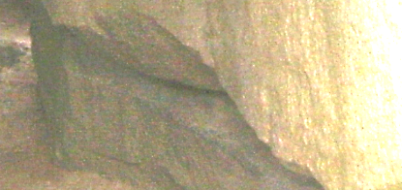
This dolmen represents the final phase of the Urdolmen type. It already has a passage and with a chamber length of 2.7 meters it is rather long. But the most spectacular feature is the northern side stone, which resides on a plinth . Both outer sides have the proportion of a trysquare 1×2 and thus the inner side fits a diagonal through two adjacent squares . The main grid of this tomb supplies for a setup via a diagonal through three adjacent squares. The end stone, southern side stone and the southern wall of
Figure 7
Dolmen 326 of Neu Gaarz.
The eastern side stone rests on a plinth. This construction can have served an easy manner to orientate the side stone very precisely.
the passage stand along diagonals in the main grid.

Serrahn 384
Unfortunately, the dolmens of Serrahn have been dismantled by the landowners in the void of authority during the unification of Germany. Luckily, Schuldt made accurate ground plans and/or excavation plans of them already. During the excavation of this dolmen, it appeared that the door slab did not rest on the threshold any longer but was placed askew . Thus, the situation of the excavation plan seems to be a secondary construction. Within the geometrical setup it emphasizes the special position of the interstice of the left wall. With or without, the setup does not change.

Serrahn 385b
This is one of the dismantled dolmens of Serrahn and thus the geometrical setup is based on the field plan of Schuldt solely. This does not seem to be a problem, since dolmen 385b has a double grid (discussed further on), which would not appear in an inaccurate ground plan. Moreover, the dolmen can be compared to D22 in the Netherlands (see PTS-5).

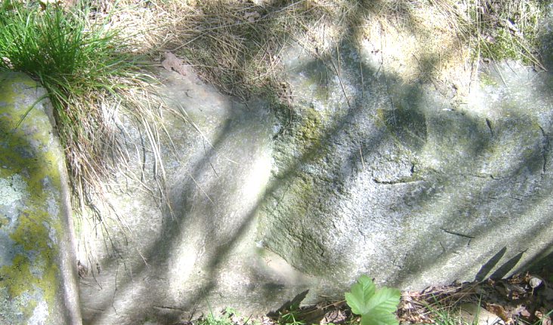
Frauenmark 409
Figure 8
In the end stone of Frauenmark 409 a prismatic hole has been carved (blue dashed lines).

In this well preserved Urdolmen we find the most perfect application of a prismatic marking. It has been carved in the end stone (figure 8) and seems to highlight the geometrical configuration of the dolmen. While the northwestern side stone disturbs the idea of paralleling walls, the marking does 'repair' it. Another remarkable feature is seen near the entrance. Here the door slab does not fit the entrance completely. The gap is filled up by means of dry masonry.

Overview of the dolmen setups

Figure 9 shows the orientated tombs. In the titles you find the nearest village and the number of the dolmen. In parenthesis the azimuth of the grid is given. Other azimuth values can be deduced from the geometrical principles (see PTS-1). In the ground plans a grey dotted line indicates where the form of a stone could not be measured anymore. Thresholds and door slabs are coloured blue. The alignment along the grid lines seems to be one of their features. In dolmen Ruserberg 203s the hatched stones indicate a possible disturbance because of the displaced capstones.

A diagonal through a field of 2×3 squares

In PTS-4 (figure 32 and 33) and in PTS-5 (figure 5) we have encountered some setups that produce sightlines at 167º within a grid at 43º. The Dutch hunebed D22 shares the grid at 43º with D21 while both hunebedden have sightlines at 167º created in the grid. Moreover, the setup of hunebed D22 is identical to that of D13 although both tombs have different shapes. The relation between the azimuth values 43º and 167º can be described as the construction of a diagonal through a field of 2×3 squares. Apart from the TRB West Group this relation is found in the regions of the TRB North Group too. A straightforward application is found in dolmen Rotensande 64, which has its ground plan formed by a field of 2×3 squares orientated towards the cardinal points. A little less straight forward comes with the setup of Serrahn 385b, which could be linked to hunebed D22 too, because of the atypical placement of an end stone (PTS-5, figure 1). The door slab of Serrahn 385b is placed along a diagonal 2×3 and thereby confirms the grid of squares having an orientation of 56º.

Rotensande 65 (90º) Ruserberg 203s (90º+13¼º) Ruserberg 203n (90º-26½º) Serrahn 384 (13¼º)

Frauenmark 409 (90º-13¼º) Serrahn 385b (0º / 0º / 56¼º)
marking

Wetterade 209 (+3º) Hemmelmark 81 (90º-13¼º) Barkvieren Sch95 (43º / 90º-13¼º)

Panker 187 (53¼º) Darry ??? (53¼º) Rotensande 64 (90º) Rotensande 61 (36¾º)

Neu Gaarz 326 (18½º) Lehmberg 67 (13¼º)

Figure 9
The ground plans and related geometrical setups of some dolmen near the Baltic Sea. The grid orientation is given in parenthesis behind the site name. Numbering according Sprockhoff (except Sch92, which is numbered according to Schuldt).

Figure 10
The geometrical setup of the dolmens of the Ruserberg. Dolmen 203n has a straightforward setup. The setup of dolmen 203s starts off with a sightline at 43º. See the text for more details.
43º
203n
203s
In the southern Langbett on the Ruserberg in Schleswig-Holstein we find two dolmens having their end stones aligned at the same sightline of 43º. The southern dolmen can be related to the sightline because of its grid but the northern cannot. Probably the alignment results of the orientation of the Langbett. Ruserberg 203n applies a rather straight forward setup by means of a repeated diagonal through two adjacent squares. The tomb gets its grid orientation from such a diagonal and the inscribed triangle is produced by the same diagonal.

Ruserberg 203s utilises two grids. The first grid derives its orientation from a diagonal through a field of 2×3 squares. It is used to setup forked sightlines at 167º and 193º. Furthermore, it forms the base grid of a secondary grid in which the inscribed Pythagorean triangle is constructed. The same geometrical construction of forked sightlines as in Ruserberg 203s is found in the Dutch hunebedden D13 and D22 (see PTS-5). Although the setup diverges a little, the concept itself must have belonged to the mindset of the surveyors. It demonstrates once more that in Neolithic times surveying was performed by skilled surveyors who maintained interregional contacts.

An amazing application of the relation between the grids at 43º and 167º is found in the prototype Urdolmen of Barkvieren. Dolmen Sch92 has one large and one small stone, making up each side wall. It has an almost but deliberately not exact oblong ground plan (figure 12). Because two opposing edges of the tomb do make a true square angle, both other edges not being square must be intentional. This false rectangle appears to be a feature that fits exemplarily to a setup with two inscribed Pythagorean triangles in a grid. Both grid orientations are closely related to each other via the construction of a diagonal in a field of 2×3 squares. It is applied in such a way that the orientation of one grid can be created using the other grid (figure 12c). The base of the Pythagorean triangle within the first grid runs along one side wall of the tomb and that of the other grid along the opposite wall. Both

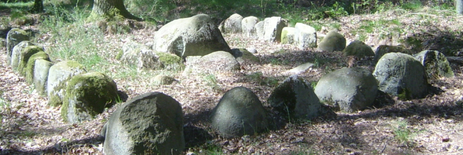
Figure 11
Urdolmen Sch92 near Barkvieren (Mecklenburg, Germany). The photograph is taken in 2007.
a b c
43º
167º
Figure 12
The ground plan of Urdolmen Sch92 is the result of two interwoven practitioner diagrams (see PTS-1).
(a) The patter in a grid at 167º fits the southern wall.
(b) The pattern in a grid at 43º fits the northern wall.
(c) The grids of both patterns can be orientated via one another.

triangle tops are positioned between the two stones of the side walls precisely. Therefore, the tomb length is a little more as twice the width. The grid at 77º / 167º produces walls at 103º / 193º. The orientation of the western wall and that of the grid can be described as 180º + 13º = 193º and 180º – 13º = 167º. These azimuths appear to be the most common orientations amongst megalithic tombs. On its turn, the grid at 43º / 133º produces walls at 106º / 196º. Although the grid orientation is applied quite often, the wall orientations are seen less common.

Schuldt typified dolmen Sch92 as a prototype Urdolmen so that it must be dated in the Frühneolitikum . This means that it is one of the earliest megalithic monuments near the Baltic Sea. Yet the Neolithic surveyor demonstrated a creative application of the Pythagorean triangle in an orientated grid. It can be doubted if he knew on forehand how to construct such a harmonious ground plan. The blue spot of figure 12a and 12b not only forms the centre point for the rotated grids but even the centre of bisection of the inscribed triangles. Maybe the surveyor tried a lot of setups and ultimately picked the best looking. Still it proves a high understanding of the possibilities of the grid. Apparently Neolithic surveyors were familiar with the grid-of-squares geometry already when megalithic building arrived in the TRB culture. Whether the surveying moved along with megalithic building or that megalithic building got incorporated in an existing surveying, cannot be answered without further study.

Reverences to the other papers of this study are abbreviated 'PTS-n', where PTS stands for the study title 'Prehistoric tomb surveying' and 'n' for the serial number of the paper.
In this paper the numbering of Sprockhoff is followed.
Because of the well-preserved state, this dolmen likely has been restored. Regrettably no restoration information could be tracked down. If the door slab has been restored it probably got its original position.
It was found the surroundings of Lütjenberg, probably near Darry, but no matching references were found.
Schuldt 1966, Second part, megalithic tomb number 29, called "Barkvieren Grab 1". In the text the years are mixed up: "erst 1956 bekannt, nachdem es 1945 durch Unberufene geöffnet und ausgeraubt worden war".
Schuldt 1972, p.19
Schuldt 1972, p.33 Abb.13
The chamber side of the stone should match a diagonal in the sub grid but diverges +2º from it. Instead of 135º it now has an azimuth of about 137º, which aligns at the southern major standstill of the moon. Perhaps the geometrical setup intended a rough alignment that had to be fine tuned afterwards.
Schuldt 1972, p.22 and p.46 Abb.24
Schuldt 1972, p.92

